Welcome

To

Cape Haze!

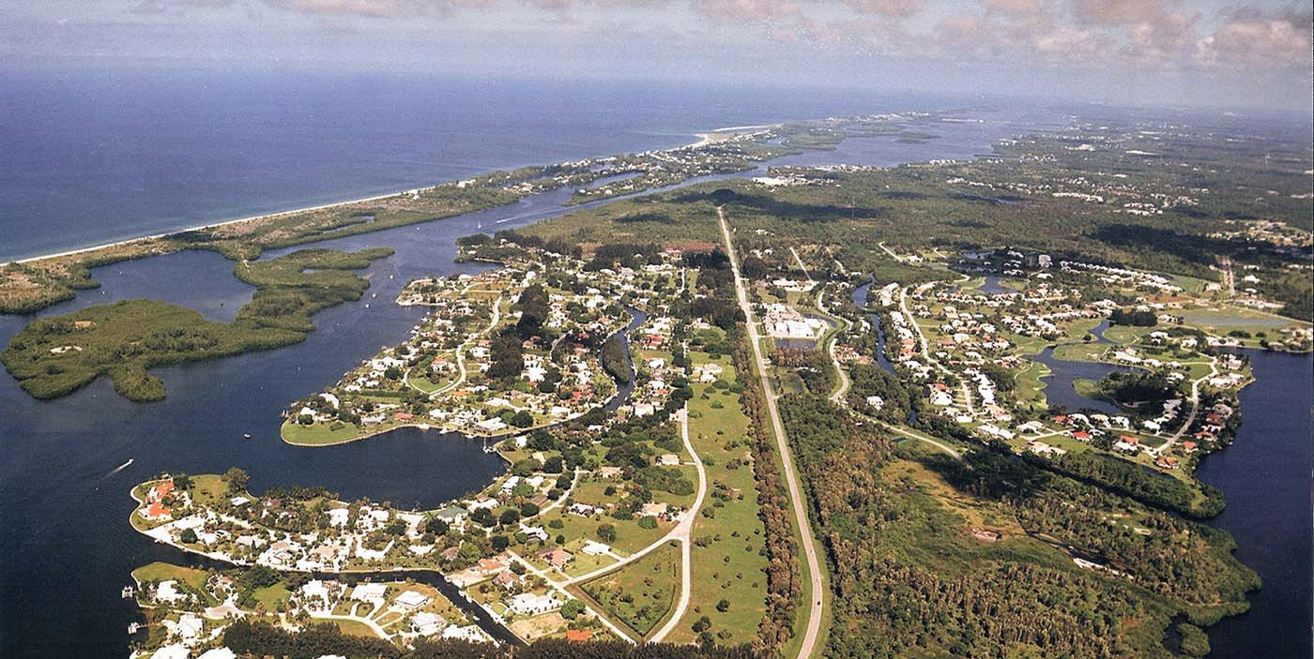

Welcome to Cape Haze!

This information packet has been prepared by the welcoming committee of the Cape Haze Property Owners Association (CHPOA). We hope you will find it a useful introduction to our wonderful area!

Contents:

Introduction to the Cape Haze Property Owners Association
• CHPOA’s Role in Our Community
• Who’s Eligible to Join CHPOA?
• CHPOA Amenities
o Community Center
o Don Pedro Island Dock and Beach Access
• Cape Haze Women’s Club
• CHPOA Membership Fees
• Additional CHPOA Information Enclosed
o CHPOA Membership Enrollment Form, Cape Haze Women’s Club Enrollment Form, Cape Haze Directory, Fountain Newsletter, CHPOA Bylaws

A Brief Cape Haze History

Maps of Our Communities
• Cape Haze, Cape Haze East, Lots near Windward

Deed Restrictions and Zoning
• Cape Haze Deed Restrictions
• Cape Haze East Property Owners Association
• Zoning in Cape Haze (West of Placida Road)

Being A Cape Haze Good Neighbor

Some Government Information You May Find Useful
• Charlotte County Offices on San Casa
• Charlotte County Government Web Sites

Additional Enclosures in Your Welcome Packet:
• List of Area Churches; Watering Regulations – Charlotte County Utilities; Garbage, Trash and Recycling Information; List of Area Golf Courses; Cape Haze Deed Restrictions; Hurricane Preparation Checklist; etc.

Introduction to the Cape Haze Property Owners Association, Inc. (CHPOA)

CHPOA’s Role in Our Community

CHPOA is a voluntary membership organization incorporated in 1969. Our Articles of
Incorporation include the following purposes for our organization, to:
• Promote Cape Haze as a desirable place to live,
• Promote the improvement of facilities and services,
• Foster the spirit of friendly cooperation among members, and extend such spirit toward new residents and new property owners,
• Encourage conservation of the natural resources of the Cape Haze area. Today, CHPOA is an active force in our community on all of these fronts.

Activities: CHPOA supports a range of social and educational activities for our members.

Amenities: We maintain our Community Center and Don Pedro island dock for the use of our members and their guests.

Community Forums: In informal discussions and through three annual membership meetings, we serve as a community forum for discussing information of importance to our community. Our Website and Facebook page provide reports on community news throughout the year.

Representation: CHPOA takes an active role in preserving the unique character and charm that is Cape Haze. By acting as a group, we have more weight and leverage than we do acting as individuals, and CHPOA successfully uses that leverage to ensure
that changes coming to our community are well-designed and supportive of our property values. Examples of past victories include design input to the Publix shopping center
on Placida Road, negotiation with the state to limit the impact of the proposed expansion of Don Pedro State Park, and defeat of a county proposal for a public boat ramp on a neighboring property.

Who’s Eligible to Join CHPOA?

The assets currently owned by CHPOA were originally part of an amenity package that was offered to property owners in three neighborhoods developed by Cape Cave and Cape Haze Corporations. Those neighborhoods were:
• Cape Haze (also sometimes referred to as Cape Haze West)
• Cape Haze East
• A specific set of lots along Coral Creek Drive, Coral Creek Circle and Arlington Drive adjacent to the Windward community (but platted separately from that community).

Current property owners (and long-term lease holders) in these three areas are eligible to join CHPOA today.

The specific lots adjacent to Windward that are eligible for CHPOA membership are indicated on the map of the Windward area included in this package. Most of the properties are on the Coral Creek side of Coral Creek Drive, with addresses ending in “0” - from 350 Coral Creek Drive to 570 Coral Creek Drive. There are three properties on Coral Creek Circle, with addresses 355 Coral Creek Drive, 4 Coral Creek Circle and
6 Coral Creek Circle. And, there’s one property on Arlington Drive, 4636 Arlington.

For residents and owners in our designated neighborhoods, there are three classes of membership:
• Regular membership is open to homeowners. It includes access to all CHPOA
functions and amenities, and the right to vote and hold CHPOA office.
• Associate membership is open to lot owners and Board approved previous homewoners. Associate members are kept advised of all CHPOA activities, but do not have voting rights or rights to access our facilities without permission.
• Temporary membership is open to persons leasing or renting residences for a year or longer. It includes all rights of regular membership except voting and holding office.

CHPOA Amenities

Community Center

Our community center is located at 180 Spyglass Alley in the Cape Haze subdivision, where Spyglass and Spaniards Road meet at the Cape Haze circle. The community center facilities include a large meeting room, a kitchen, rest rooms, and a library. A parking lot is located on the Spaniards Road side of the property.

The library offers a collection of books, games, and puzzles available to members at no cost. Recent paperback and hardback books are donated regularly.

A member may reserve the community center for private parties at no charge, with the caveat that the member is responsible for cleaning and removal of trash after the party and repair of any damages that might occur during the event. Application must be made in order to gain approval to reserve the facility.

Children and teenagers under 18 must be accompanied by an adult when using the community center.

Don Pedro Island Dock and Beach Access

In 1973, Cape Haze Corporation deeded to CHPOA 400 feet of beachfront property on Don Pedro Island facing the Gulf of Mexico, along with a 65 foot-wide access path across the island from Lemon Bay and a dock on the bayside of the island. Over the years, the original dock fell into disrepair and it was rebuilt by CHPOA in 2003.

Don Pedro Island sits across the Intracoastal Waterway from Cape Haze and is accessible only by boat. Our private community beachfront is located just to the north of Don Pedro Island State Park.

The CHPOA dock is available to members only and is located across the bay from the north end of Cape Haze West. When you join CHPOA, be sure to ask for information on how to approach the dock by boat. – Like most waterways around here, much of the water near the dock is quite shallow and you’ll need directions to find the access channel. You will find a map of Lemon Bay and the CHPOA dock on our website, www.capehaze.org.

Cape Haze Women’s Club

By tradition, the Cape Haze Women’s Club has coordinated the social activities of CHPOA and offered various events for the women of our community. Today, many of the Club’s activities are attended by both our male and female CHPOA members and guests. The Women’s Club meets once a month (November thru April) with a short business meeting and program.

The Club members continue to organize a wide-range of social events. Examples of past events include a fall “welcome back” party for our seasonal residents, a holiday dinner-dance, a wine-tasting party, a New Year’s Day brunch, golf tournaments, and a Spring Fling party.

Other activities include a book club, aerobics classes several days a week, monthly Friday night socials, and excursions to cultural events and to nearby sites of interest. Examples of past trips include a historical tour in Punta Gorda, a shell collecting expedition and lunch on Palm Island, and a sea grass wading adventure at Cedar Point Environmental Park.

The Women’s Club has also adopted a section of Placida Road for roadside cleanup and volunteers periodically hold morning clean-up sessions to keep the highway looking “good”.

For information on upcoming activities and events, check our community website, www.capehaze.org, or stop by the Community News bulletin board located near the flagpole at the Community Center.

CHPOA Membership Fees

Membership dues for CHPOA are determined annually based on recommendations from the board of directors and a vote by the membership.

For 2018, the dues are $275.00, prorated by month for new residents who join during the course of the year.

There is also a separate $150.00 fee referred to as “CAM” or the Common Area Maintenance fee. This fee is applicable only for property owners in the Cape Haze subdivision (west of Placida Road). It is used to maintain the landscaping for the three Cape Haze subdivision entrances, to maintain the fountain, and for tree trimming and other maintenance work along our roads and canals.

Additional CHPOA Information enclosed in “Your Welcome Packet”:

We have included in this welcome packet the enrollment forms for CHPOA and Women’s Club membership, a copy of the CHPOA bylaws, CHPOA Deed Restrictions and a Women’s Club brochure. All of this information and much more can be found on the CHPOA website at www.capehaze.org.

Please contact any member of the welcoming committee or the CHPOA board if you have questions or would like additional information. You’ll find phone numbers on the website.

We hope that you will elect to join our fun and dynamic association!

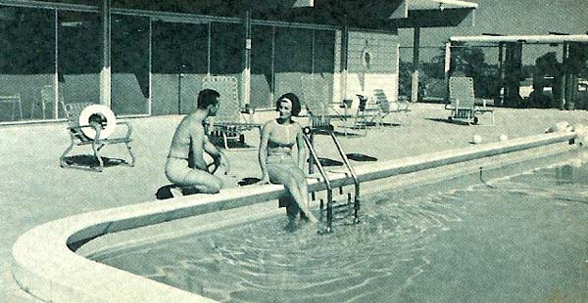A Brief Cape Haze History

The lands and waters around the Cape Haze peninsula were occupied for thousands of years by Native Americans who lived primarily off the bounty of the sea. Around Charlotte Harbor today, there remain a significant number of shell middens and other historical sites through which archeologists are piecing together the lifestyles of the Calusa and Timucua tribes who controlled this area until the arrival of European explorers.

In the late 19th century, fishing and farming settlements developed on the Cape Haze peninsula. Grove City was featured in the 1893 Chicago World’s Fair and a fishing community developed at Placida. Between 1905 and 1909, the Charlotte Harbor & Northern Railroad laid tracks thru the peninsula (near today’s Highway 771) and across a newly created railroad bridge to Boca Grande to haul phosphate for loading aboard ships at Boca Grande pass.

In the 1950s, Alfred and William Vanderbilt purchased 35,000 acres of land on the Cape
Haze peninsula for use primarily as a cattle ranch. Their holdings included most parts of the subdivisions known today as Rotonda, South Gulf Cove, Windward, Cape Haze East and Cape Haze.

The Vanderbilt brothers began developing Cape Haze and Cape Haze East in the early
1950s. Seawalls were constructed and fill dirt brought in to create the canals and shape the land areas that make-up the Cape Haze subdivision today. In the early days, Cape Haze Drive continued west via a bridge over Lemon Bay onto Don Pedro Island. When the Intracoastal Waterway was dredged in the early 1960s, the bridge between Cape Haze and Don Pedro was permanently removed.

Pictures from a 1960s Cape Haze Corporation brochure:
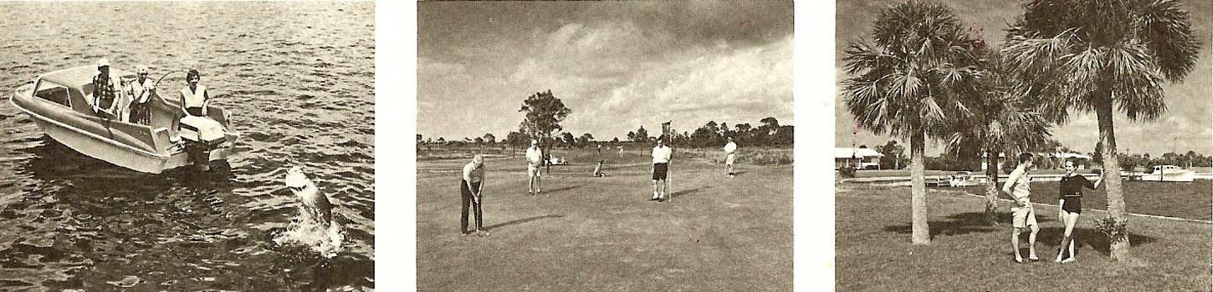

Here’s a description of the early days of Cape Haze written by Diane Brown, a Cape
Haze resident from 1985 to 2000:

CAPE HAZE — A GLIMPSE OF THE PAST

“Tommy Thompkins called us while we were back in Michigan and said to get back here. He claimed that the storm had tarpon so thick you could walk on their backs from the seawall clear across to the mangroves.” Marion Arcan is just one of the original residents of Cape Haze that can relate the pulse of a far away waterfront community that drew the original residents.

To see the beginning of Cape Haze, we look back to 1951, when William H. and Alfred G. Vanderbilt, descendents of the renowned financier, Cornelius Vanderbilt, saw the greater Cape Haze area only as prime land for their 2-V Ranch. With a flourishing cattle enterprise, Alfred, quite the sportsman, built a house in Cape Haze. They expanded their focus and were awarded gas and oil exploration leases. Drilling was done east of SR 771, but their “big one” never came in. Next they were drawn to a vision of Cape Haze as an upscale “planned, protected community for vacation, residences and retirement homes.” A friend of Alfred’s, Jim Costigan, headed the real estate venture. In 1967, with their mortgage nearly cleared, William sold most of their holdings to Alfred. Late in 1969, Alfred sold the ranch to Cavanagh Leasing Corporation of Miami — Cavanagh’s Cape Cave Corporation furthered development of Cape Haze.

But was Tommy Thompkins right about the tarpon? The fish stories get bigger with the passing years, but early residents swear that the waters were so clear you could see hundreds of fish feeding right beneath the docks. Tommy knew because Tommy was the Cape Haze Fire & Sheriff Patrol — with a fire truck parked right by the entrance — close at hand to his gatehouse. He never really closed the gates at Cape Haze Drive, but everyone stopped to talk to Tommy when they drove in. If a resident went up north, Tommy watched their houses and called with big news — like the influx of tarpon.

What were the days like in Cape Haze of yore? Before the intracoastal waterway was finished, you had your choice of driving across the Cape Haze Drive bridge, down the little road, across another bridge and you’d be right on the private Cape Haze beach — what is now part of Don Pedro State Park (our private beach is now farther north). You’d unlock your little beach shed — they were built two by two right on the beach — and take out your beach chairs and grill for a grand picnic. Or you could take the community barge, fondly known as Lollipop, from its dock near the bridge over Capstan Cut to the beach. Duffers might trek to the Cape Haze Golf Course and pro shop — nine of the finest holes around. Or perhaps you’d want to try your hand at trap or skeet shooting at the Cape Haze Gun Club behind the golf course. Guests could fly in to the Cape Haze Air Field, with its 2,800 feet of landing strip. The Cabana Club and pool were always top choices.

Early Cape Haze sales brochures touted the community as “substantial, distinguished, gracious.” Perhaps it was — and today it remains unique!

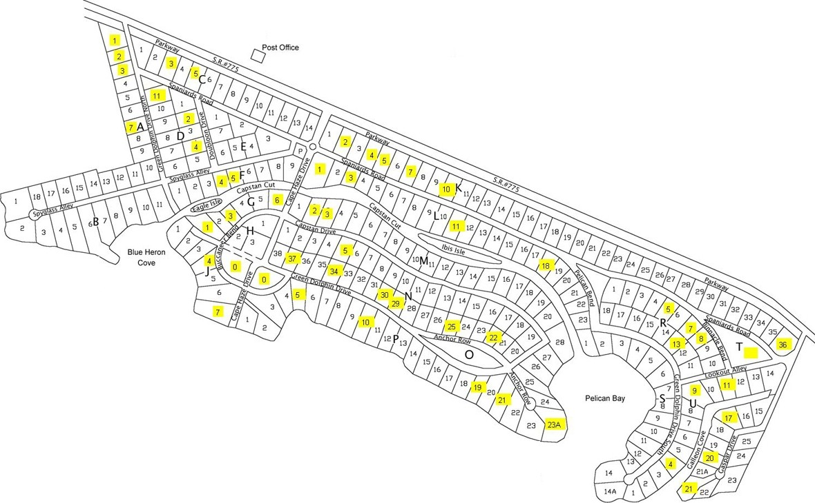Cape Haze
with zoning as of August 10, 2004
red

D Properties Remaining Zoned RSF 3.5

The information depicted in this graphic is believed to be accurate as of August
10, 2004, but is not guaranteed bv CHPOA and should not be used as a legal
reference.

Cape Haze East

The Cape Haze East subdivision is located between Placida Road and Amberjack Cove as shown in the map below. It includes approximately 115 lots (shown in turquoise on the map) located on Cobia Drive, Barracuda Drive, Bonita Street and Pompano Street.

CHPOA Eligible Lots in the Windward Area

The lots eligible for CHPOA membership in the Windward area are addresses on the
Coral Creek side of Coral Creek Drive ending in “0”, from 350 Coral Creek Drive to 570
Coral Creek Drive, along with 4636 Arlington Drive and three lots on Coral Creek Circle (addresses 355 Coral Creek Drive, 4 Coral Creek Circle and 6 Coral Creek Circle). The eligible lots are shown in yellow on the map below.

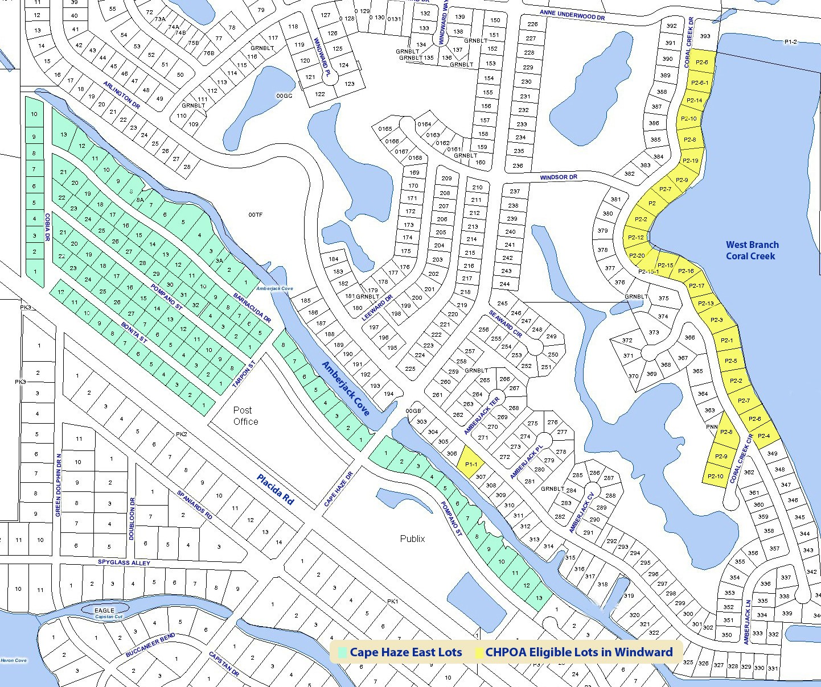

Deed Restrictions and Zoning

Cape Haze Deed Restrictions

When Cape Haze was platted in 1953, deed restrictions were created to run with the land. Specifications in the deed restrictions applied to Cape Haze properties both east and west of Placida Road, with some variations called out for properties east of the highway. In 1983, Cape Haze Corporation assigned CHPOA non-exclusive rights to enforce some, but not all, of the Cape Haze deed restrictions. Over the years, there was limited enforcement.

Because the original deed restrictions were set to expire in 2003, CHPOA undertook an effort to create a new, stronger set of restrictions for all of Cape Haze. However, Florida law required that 100% of Cape Haze property owners approve any new restrictions. A
100% consensus could not be achieved. So, the attempt to create new standards failed. And, in 2003, CHPOA paid for legal counsel to re-file and extend the original restrictions for an additional 30 years through Florida's Market Record Title Act (MRTA).

Are these deed restrictions enforceable? Yes. If you own property in Cape Haze, you should have received a copy of the deed restrictions applicable to your land as part of your real estate purchase. We’ve enclosed a copy of the current deed restrictions in this packet for your reference.

The restrictions, when adhered to, offer unique opportunity for cohesion among all of us as neighbors. By treating these restrictions as minimum standards for the condition and treatment of our property within the neighborhood, we honor ourselves and show respect to our neighbors by allowing them the maximum benefit of owning property in this beautiful community with such a rich history.

In an effort to utilize our limited resources effectively over the years past, CHPOA has relied on various measures ranging from letters, discreet discussions with owners, and public reminders in our newsletters to enforce the deed restrictions. Unfortunately, the efficacy of these more gentle measures has waned as adherence to the restrictions has slipped.

CHPOA will therefore be stepping up enforcement measures in 2019 with an initial focus on the most egregious violations, these being the parking of boats, trailers, and campers on properties, and the non-maintenance of property. Please see the following 2018 Florida Statutes regarding enforcement rights:
2018 Florida Statutes-Homeowner Associations

720.305 Obligations of members; remedies at law or in equity; levy of fines and suspension of use rights.—
(1) Each member and the member’s tenants, guests, and invitees, and each association, are governed by, and must comply with, this chapter, the governing documents of the community, and the rules of the association. Actions at law or in equity, or both, to redress alleged failure or refusal to comply with these provisions may be brought by the association or by any member against:
(a) The association;
(b) A member;
(c) Any director or officer of an association who willfully and knowingly fails to comply with these provisions; and
(d) Any tenants, guests, or invitees occupying a parcel or using the common areas.
The prevailing party in any such litigation is entitled to recover reasonable attorney fees and costs. A member prevailing in an action between the association and the member under this section, in addition to recovering his or her reasonable attorney fees, may recover additional amounts as determined by the court to be necessary to reimburse the member for his or her share of assessments levied by the association to fund its expenses of the litigation. This relief does not exclude other remedies provided by law. This section does not deprive any person of any other available right or remedy.
(2) The association may levy reasonable fines. A fine may not exceed $100 per violation against any member or any member’s tenant, guest, or invitee for the failure of the owner of the parcel or its occupant, licensee, or invitee to comply with any provision of the declaration, the association bylaws, or reasonable rules of the association unless otherwise provided in the governing documents. A fine may be levied by the board for each day of a continuing violation, with a single notice and opportunity for hearing, except that the fine may not exceed $1,000 in the aggregate unless otherwise provided in the governing documents. A fine of less than $1,000 may not become a lien against a parcel. In any action to recover a fine, the prevailing party is entitled to reasonable attorney fees and costs from the non-prevailing party as determined by the court.
(a) An association may suspend, for a reasonable period of time, the right of a member, or a member’s tenant, guest, or invitee, to use common areas and facilities for the failure of the owner of the parcel or its occupant, licensee, or invitee to comply with any provision of the declaration, the association bylaws, or reasonable rules of the association. This paragraph does not apply to that portion of common areas used to provide access or utility services to the parcel. A suspension may not prohibit an owner or tenant of a parcel from having vehicular and pedestrian ingress to and egress from the parcel, including, but not limited to, the right to park.
(b) A fine or suspension levied by the board of administration may not be imposed unless the board first provides at least 14 days’ notice to the parcel owner and, if applicable, any occupant, licensee, or invitee of the parcel owner, sought to be fined or suspended and an opportunity for a hearing before a committee of at least three members appointed by the board who are not officers, directors, or employees of the association, or the spouse, parent, child, brother, or sister of an officer, director, or employee. If the committee, by majority vote, does not approve a proposed fine or suspension, the proposed fine or suspension may not be imposed. The role of the committee is limited to determining whether to confirm or reject the fine or suspension levied by the board. If the proposed fine or suspension levied by the board is approved by the committee, the fine payment is due 5 days after the date of the committee meeting at which the fine is approved. The association must provide written notice of such fine or suspension by mail or hand delivery to the parcel owner and, if applicable, to any tenant, licensee, or invitee of the parcel owner.
(3) If a member is more than 90 days delinquent in paying any fee, fine, or other monetary obligation due to the association, the association may suspend the rights of the member, or the member’s tenant, guest, or invitee, to use common areas and facilities until the fee, fine, or other monetary obligation is paid in full. This subsection does not apply to that portion of common areas used to provide access or utility services to the parcel. A suspension may not prohibit an owner or tenant of a parcel from having vehicular and pedestrian ingress to and egress from the parcel, including, but not limited to, the right to park. The notice and hearing requirements under subsection (2) do not apply to a suspension imposed under this subsection.
(4) An association may suspend the voting rights of a parcel or member for the nonpayment of any fee, fine, or other monetary obligation due to the association that is more than 90 days delinquent. A voting interest or consent right allocated to a parcel or member which has been suspended by the association shall be subtracted from the total number of voting interests in the association, which shall be reduced by the number of suspended voting interests when calculating the total percentage or number of all voting interests available to take or approve any action, and the suspended voting interests shall not be considered for any purpose, including, but not limited to, the percentage or number of voting interests necessary to constitute a quorum, the percentage or number of voting interests required to conduct an election, or the percentage or number of voting interests required to approve an action under this chapter or pursuant to the governing documents. The notice and hearing requirements under subsection (2) do not apply to a suspension imposed under this subsection. The suspension ends upon full payment of all obligations currently due or overdue to the association.
(5) All suspensions imposed pursuant to subsection (3) or subsection (4) must be approved at a properly noticed board meeting. Upon approval, the association must notify the parcel owner and, if applicable, the parcel’s occupant, licensee, or invitee by mail or hand delivery.
(6) The suspensions permitted by paragraph (2)(a) and subsections (3) and (4) apply to a member and, when appropriate, the member’s tenants, guests, or invitees, even if the delinquency or failure that resulted in the suspension arose from less than all of the multiple parcels owned by a member.

While it is our most sincere wish that matters do not escalate to a state that will require the employment of such costly resolutions for all of us, the matter of non-compliance has reached a point where we feel compelled to act.

Cape Haze East Property Owners Association

During the discussions on the deed restrictions topic in 2002 and 2003, CHPOA board members talked on several occasions with Mr. Roberto Iglesias, who represented the owners of a significant number of properties in Cape Haze East and in Cape Haze. Because properties under control of Mr. Iglesias represented a majority of lots in Cape Haze East, he was able to form a new organization for that area to take over the responsibilities originally held by Cape Haze Corporation for administering the deed restrictions.

The Cape Haze East Property Owners Association was formed in 2003 and if you own property in this subdivision, you should receive separate correspondence from that association on their role and activities. Cape Haze East Property Owners are invited to join Cape Haze Property Owners Association, Inc. with and Associate Membership as well and participate in all social activities.

Zoning in Cape Haze Subdivision (West of Placida Road)

Property owners in the Cape Haze subdivision (west of Placida Road) may want to check the current zoning of your property to determine if it is zoned RSF 2.0 or RSF 3.5. RSF stands for Residential Single Family. The number refers to the allowable number
of residences per acre of property. In other words, either 2 residences per acre or 3.5 residences per acre.

Because of past questions about Cape Haze subdivision deed restrictions, CHPOA explored other ideas for protecting the traditionally large (greater than ½ acre) lots in Cape Haze from being sub-divided. Changing lots from RSF 3.5 to RSF 2.0 zoning was a way to maintain the ½ acre minimum. The RSF 2.0 zoning also carries some larger setback distances for improvements on each lot. These setback requirements more closely map to those in the original deed restriction documents.

Over 80% of the lot owners in the Cape Haze subdivision agreed that moving to RSF
2.0 was a desirable zoning change and authorized CHPOA to represent them in a voluntary request to Charlotte County to switch to RSF 2.0 zoning. The Charlotte County Commission approved the requested changes in 2004.

The map of the Cape Haze subdivision included earlier in this document shows the lots that our CHPOA records indicate did not change to RSF 2.0 zoning as part of the 2004 change and therefore remain zoned RSF 3.5. (Please note that this map is not a legal representation of the zoning of your lot. Always check with Charlotte County and your attorney to insure correct zoning and legal information.)

If you find that your Cape Haze property was not included in the original rezoning request, but that you would like to rezone to RSF 2.0 in the future, please inform a member of the CHPOA board of directors. Based on interest from owners, the CHPOA board may work with you to facilitate an additional rezoning request.

Being a Good Cape Haze Neighbor

Forgetting about legal enforcement, deed restrictions, and zoning, what we all want is to live in a nice, friendly neighborhood surrounded by good and caring neighbors.

In 2005, the CHPOA Board of Directors asked Gil Bricault and Hal Johnson to study this very subject and to seek out guidance from their fellow neighbors on exactly what could be defined as a “good neighbor”. After careful study and input from various sources, it was determined that good neighbors share certain qualities that fall into three
categories; first, they are supportive of their neighborhood: second, they respect their neighbors’ rights and property, and thirdly, they are concerned for the well-being of their neighbors.

From this, we have all agreed on what makes a “Cape Haze Good Neighbor”. It is the hope that we all share these values:

A Cape Haze Good Neighbor

1. Is supportive of their neighborhood.
9 Is a member of CHPOA and a supporter of CAM.
9 Agrees that we all share in the responsibility in the care of our neighborhood.
9 Understands that although we may not all always agree on every single item, there are indeed decisions that must be made for the common good.

2. Respects their neighbors’ Rights and Property.
9 Agrees that how we maintain our properties has an impact on our neighbor’s property.
9 Respects noise levels as they also may affect their neighbors.
9 Is considerate of their pets and how they may also affect their neighbors.
9 Realizes that any home occupation should be performed in such a way as to not interfere with their neighbors. This would include items such as traffic, parking, and noise. It is also understood that no home occupation shall include retail.
9 If a boat and/or boat trailer must be kept at the property, although strongly discouraged, it should be:
o Never parked in the front yard
o Should be completely screened from view from the street view

3. Is concerned for the well being and security of all.
9 Keeps a watchful eye for suspicious activities in the neighborhood.
9 Has an awareness of the well being of their neighbors.
9 If their neighbor is away, notifies them of any changes to their property.

“Being a good neighbor is the first step to having good neighbors”

Some Government Information You May Find Useful

Charlotte County Government Offices on San Casa Drive

If you head north on Placida Road (Highway 775) toward Englewood, you’ll reach a stop light in Grove City for the street called San Casa. Turn right on San Casa to reach the Charlotte County Government Offices at 6868 San Casa Drive.

Among the many county and state functions that can be completed at these offices are obtaining Florida automobile and boat license plates, paying property taxes, getting your Florida driver’s license, acquiring a fishing license, and requesting a Charlotte County home burglar alarm permit.

Government Websites

Charlotte County posts a lot of helpful information on the web. The main county government website is www.charlottecountyfl.com. It has a wide-range of current and background information about the County, including the procedure for requesting a Charlotte County Welcome Package.

Two other county websites that you may find useful are www.ccappraiser.com, for property appraisal information, and www.ccgis.com, the county’s geographic mapping site.

If you’re new to Florida, www.myflorida.com is the primary state government website. There you’ll find information on obtaining and renewing a Florida driver’s license and on many other topics.

Additional Information Enclosed in Your Welcome Packet

You’ll find several other pieces of information enclosed in the welcome packet that is provided to you by or Welcoming Committee, including:
• A list of area churches
• Charlotte County Utilities watering regulations
• Garbage, trash, and recycling procedures
• A list of area golf courses
• Hurricane preparation information
• Other informational brochures you may find helpful

Speaking of hurricanes, as you probably know, we had a very close call here in 2004 and again in 2017. We were all reminded that it pays to prepare early and thoroughly for hurricane season. So, we encourage you to take the time soon to consider and implement your personal hurricane plans!

We live in a wonderful and unique place. Congratulations on your decision to buy here. And, one more time: Welcome to Cape Haze!

Hope to see you at our upcoming CHPOA meetings and events!

The CHPOA Welcoming Committee

